**Assignment 3**

Use one of the services like translate, transcribe, Rekognition, etc. and upload an appropriate file in S3 (depending on the target AI service, upload different file formats). That upload should triggers a lambda function code and use that event to learn about the location of object in the S3 bucket. After that, pass that object to the AI service to do the job like translation, or detecting some sentiment or detecting text inside image, based on the chosen AI service. The result of that AI service should be either printed in Lambda function or show in cloudwatch or save in S3.

Step 1: Create S3 Bucket and Inside it Create a Folder.

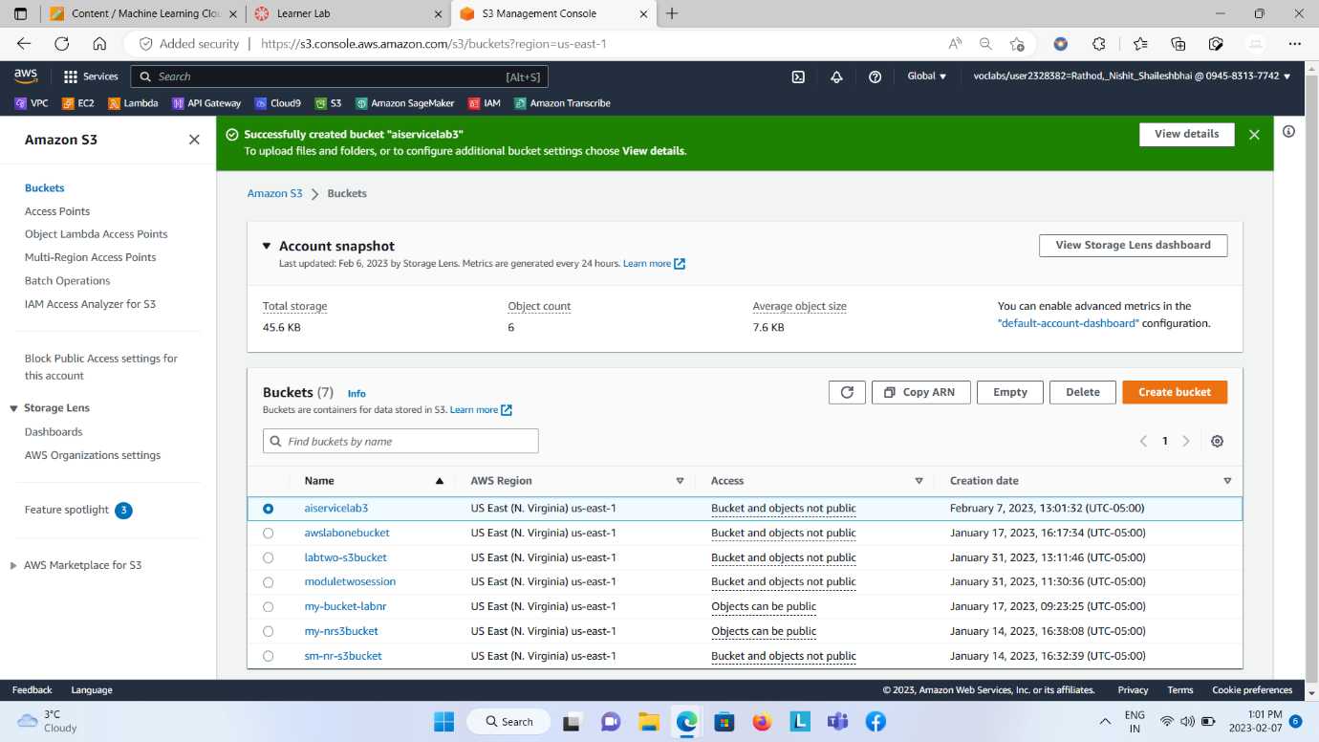

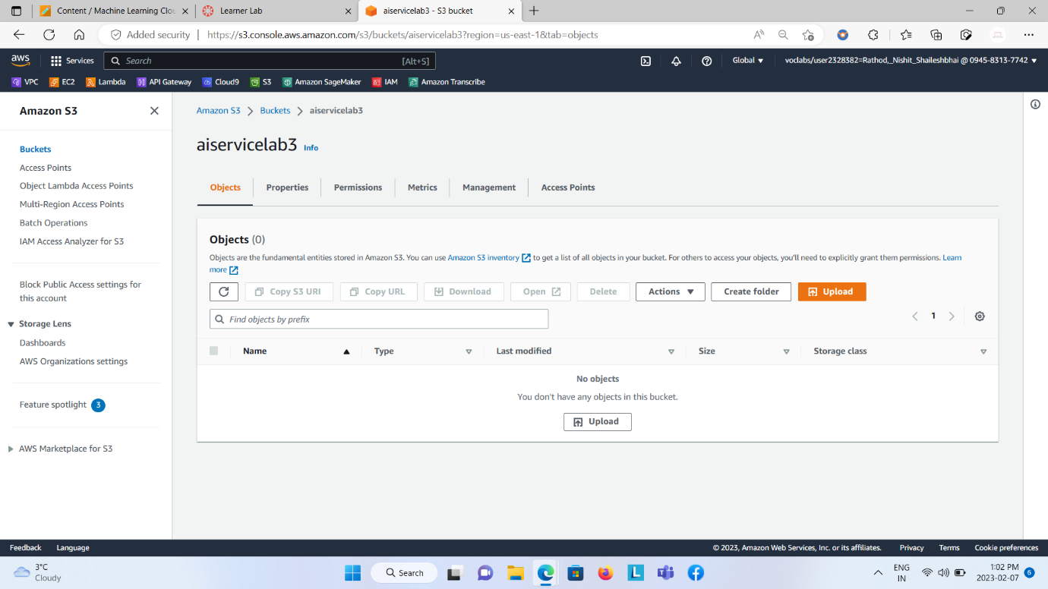  
  
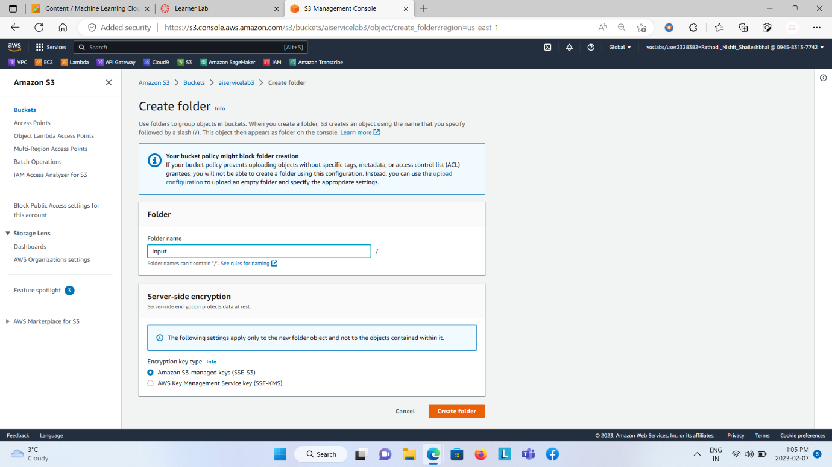  
  
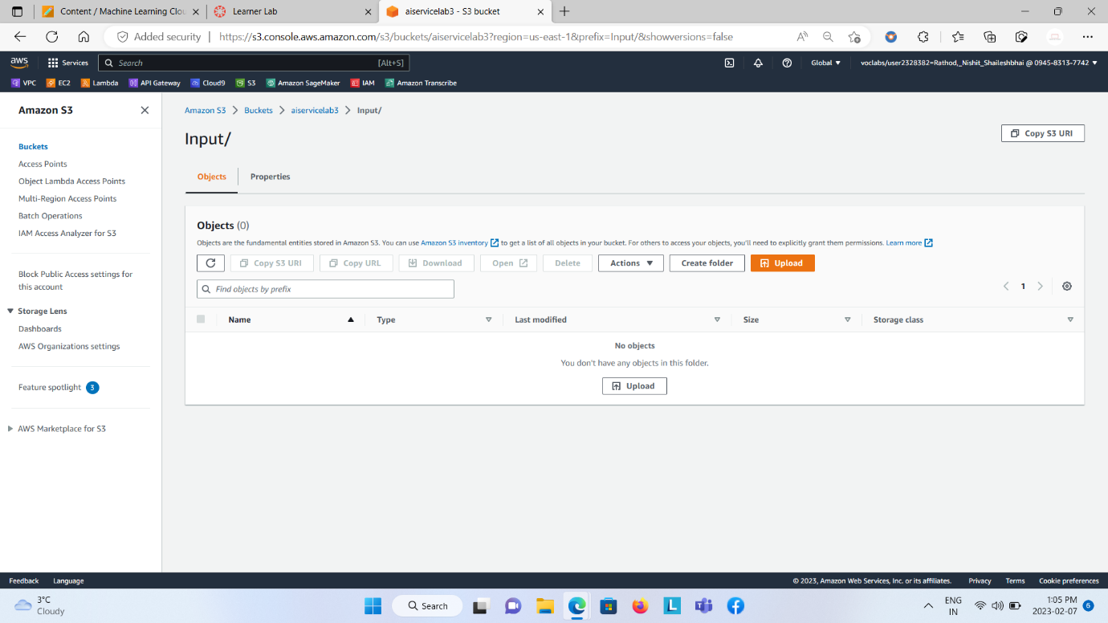

Step 2: Create Lambda Function One and add S3 Trigger to it.

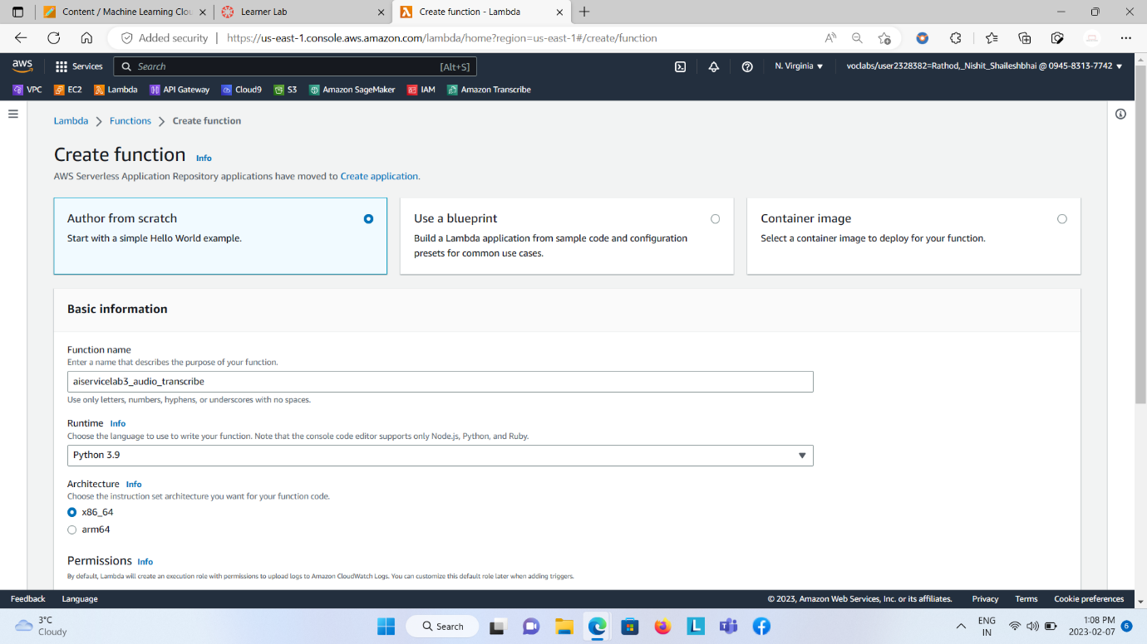  
  
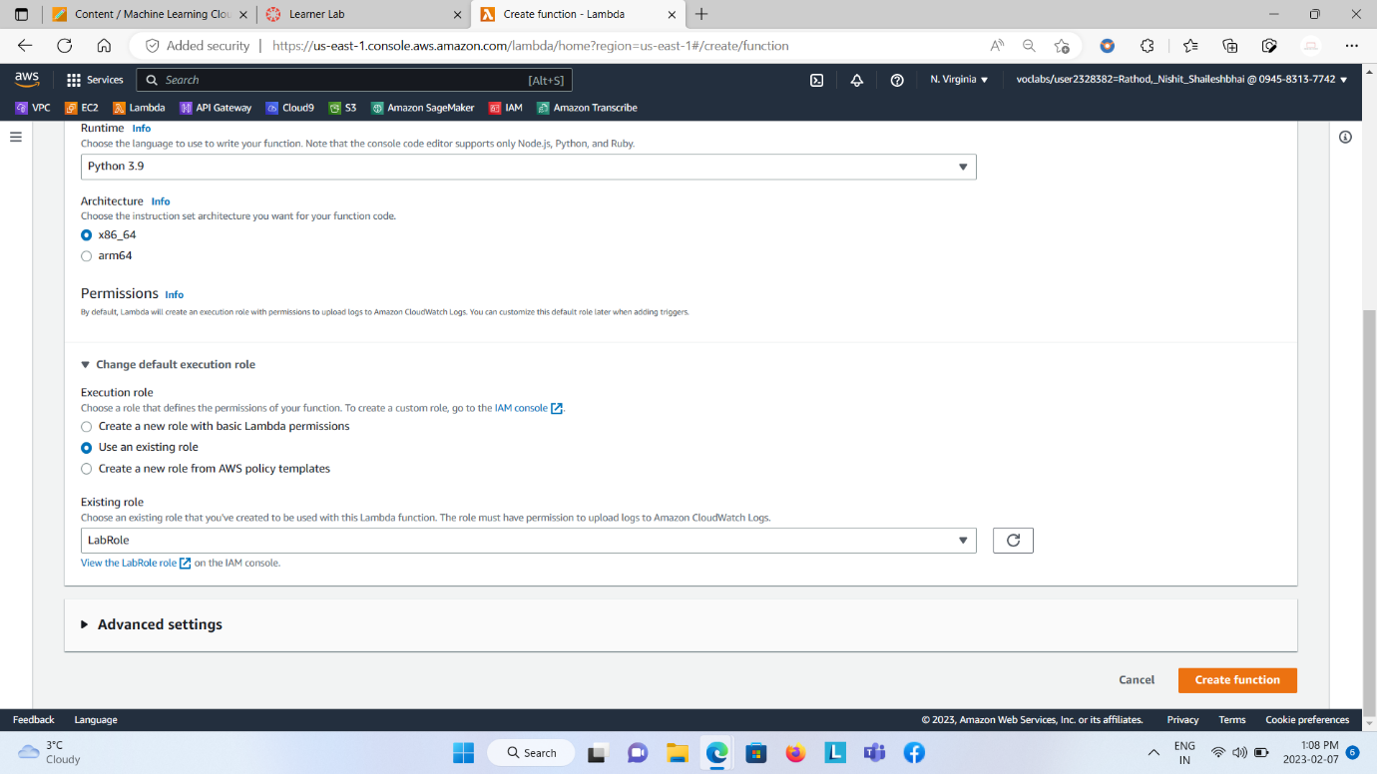  
  
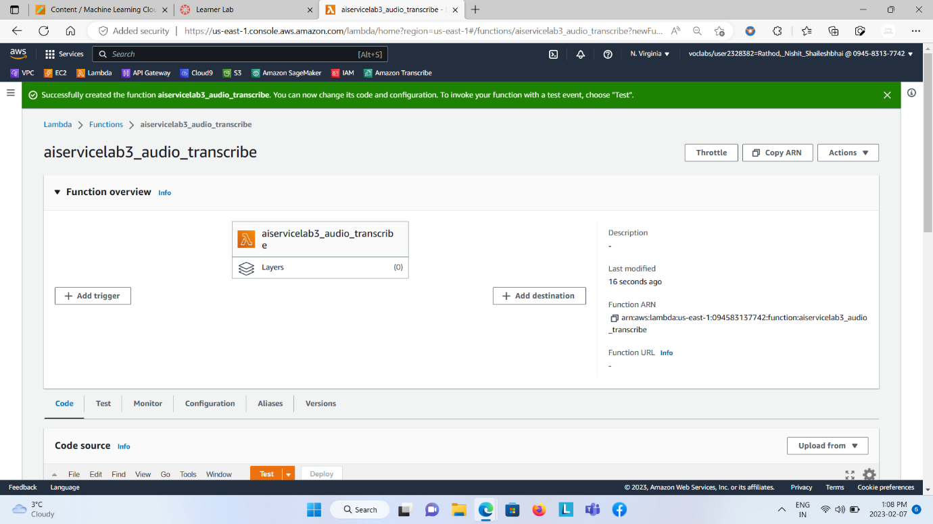  
  
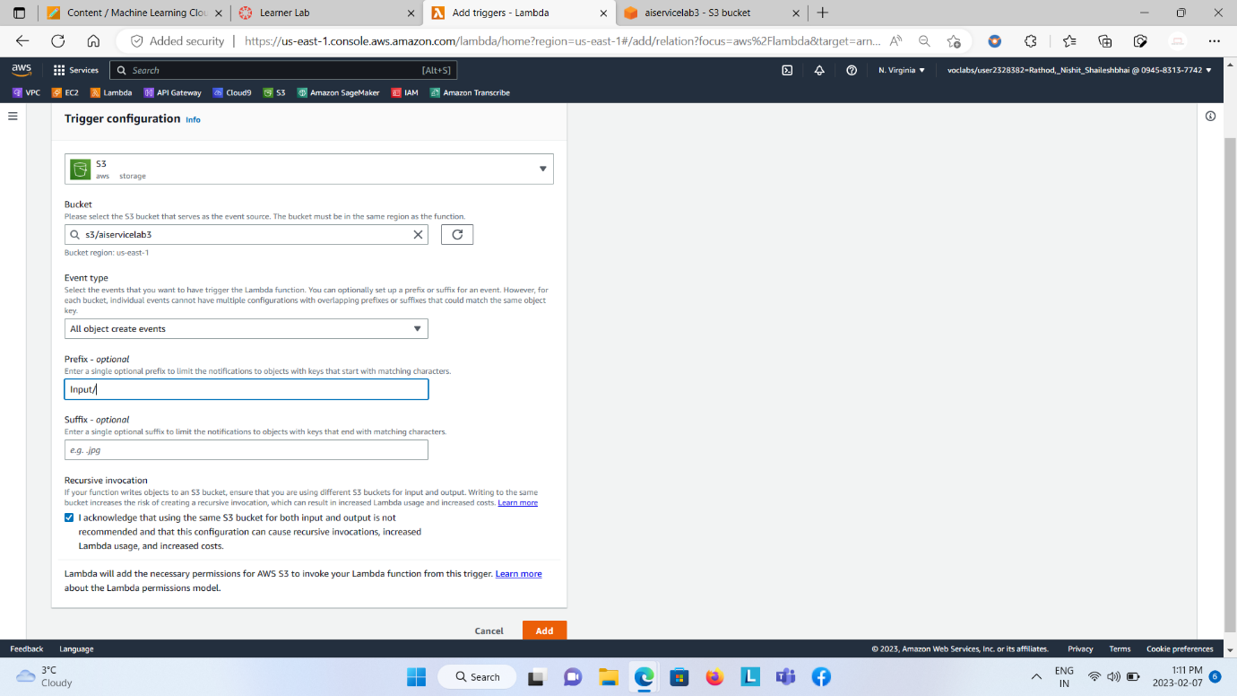  
  
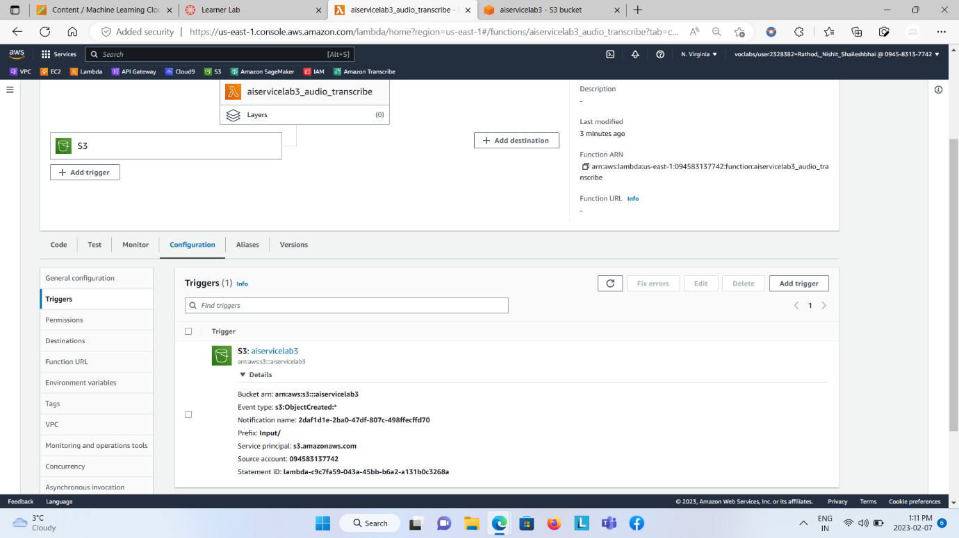  
Write the code into it.  
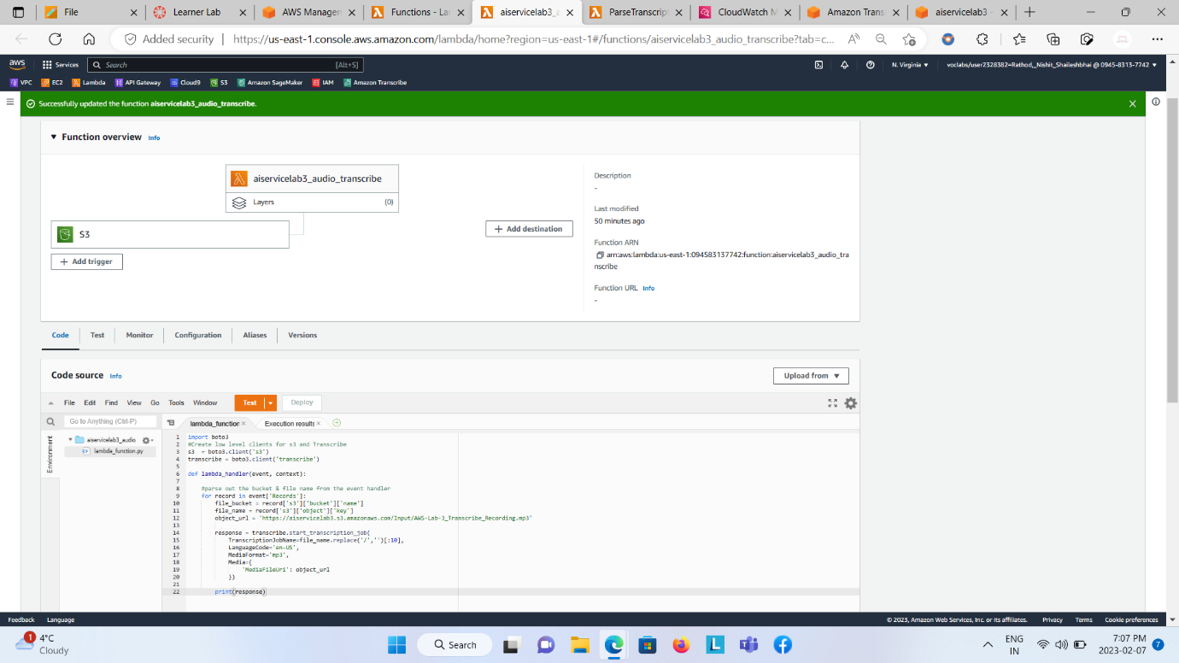

Step 3: From Configure Test Event, create new event and attach s3-put template.

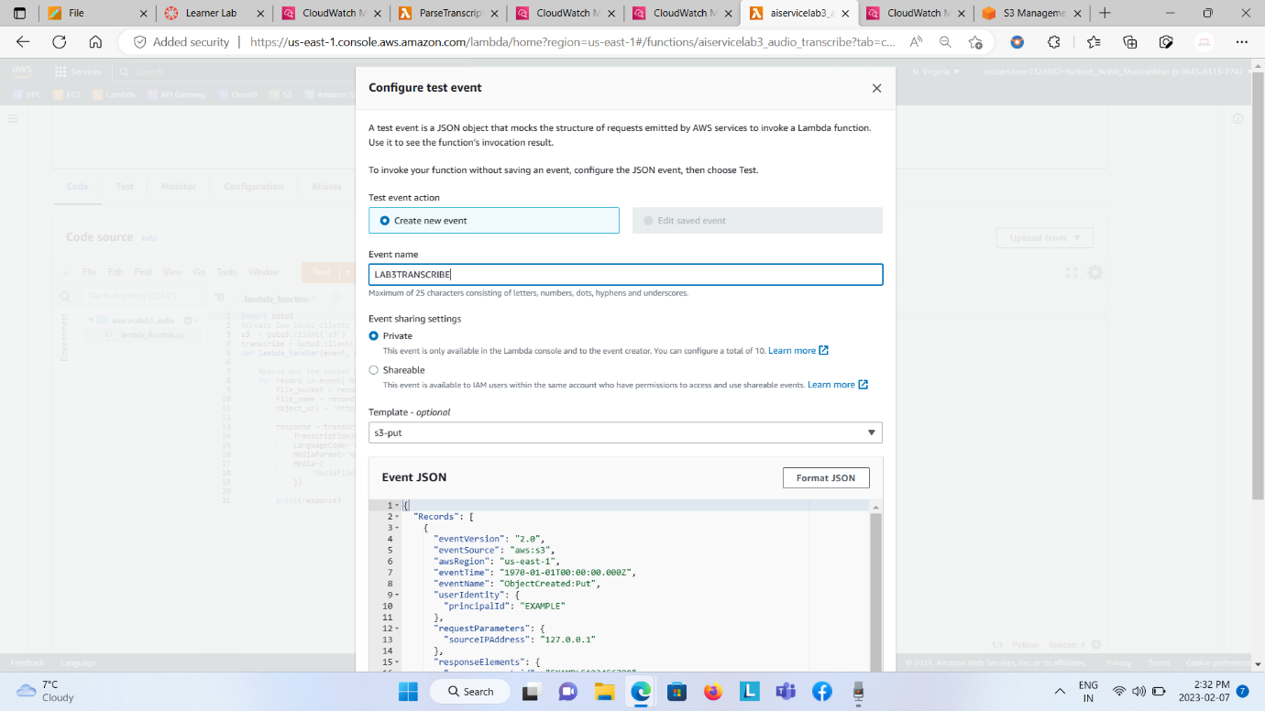

Step 4: Create Lambda Function Two and add CloudWatch Trigger to it.

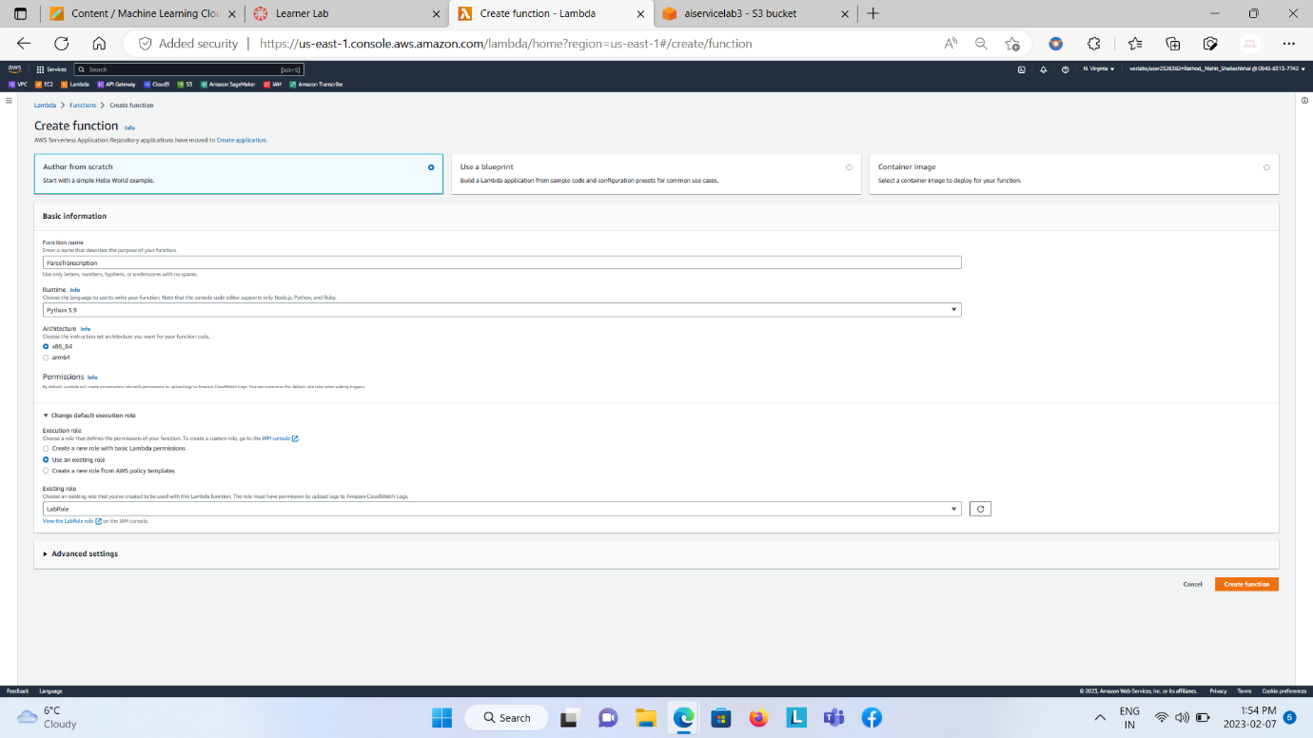  
  
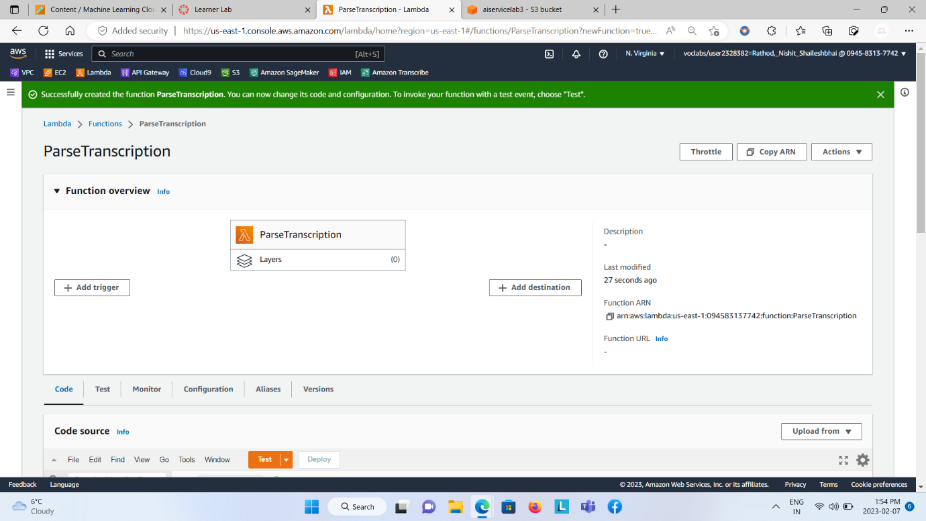  
  
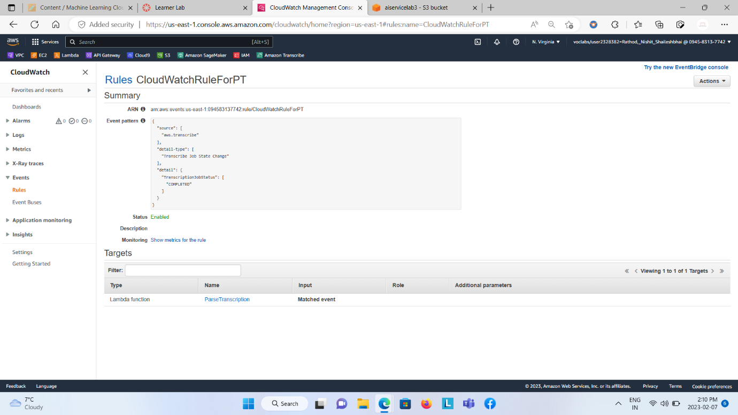

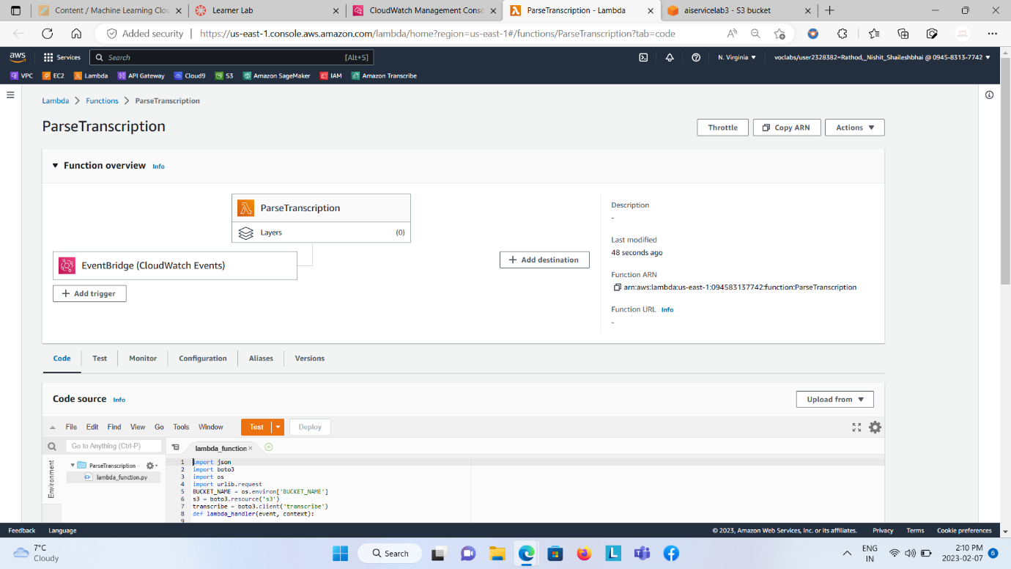

Write the code into it.

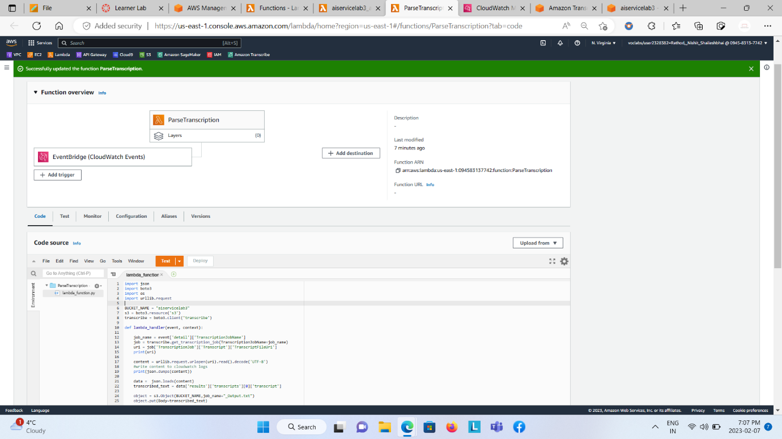

Step 5: Upload .mp3 file into the S3 bucket, inside the created folder.

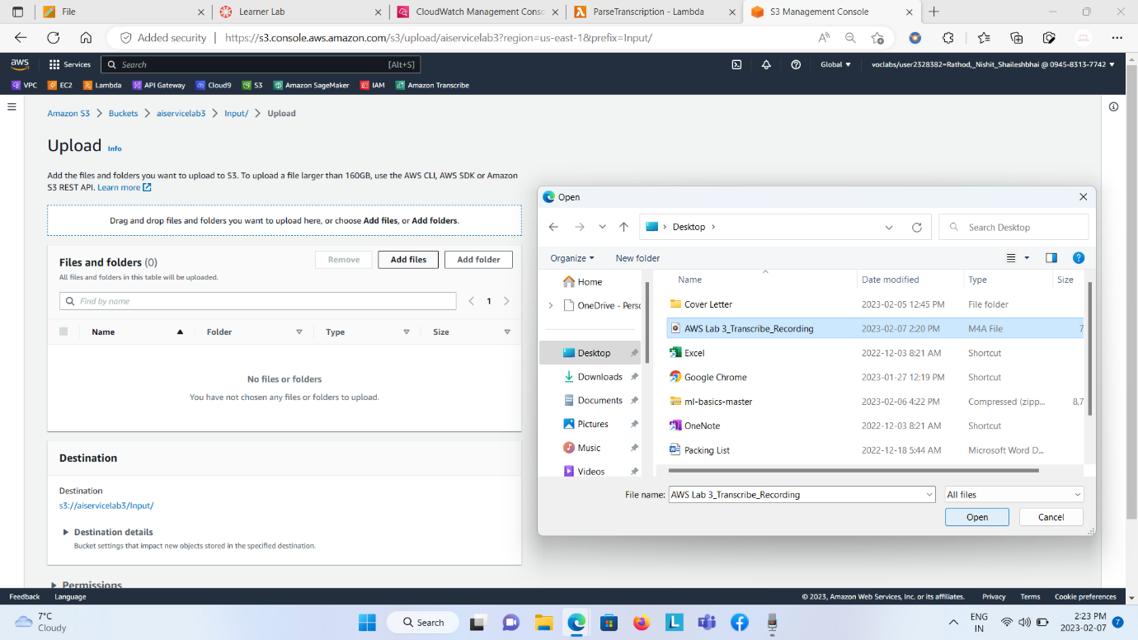  
  
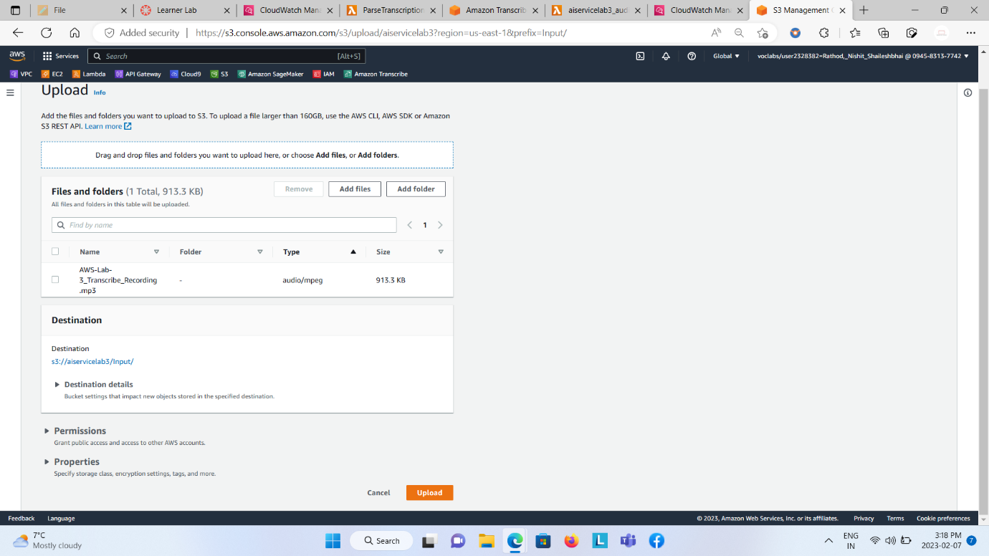  
  
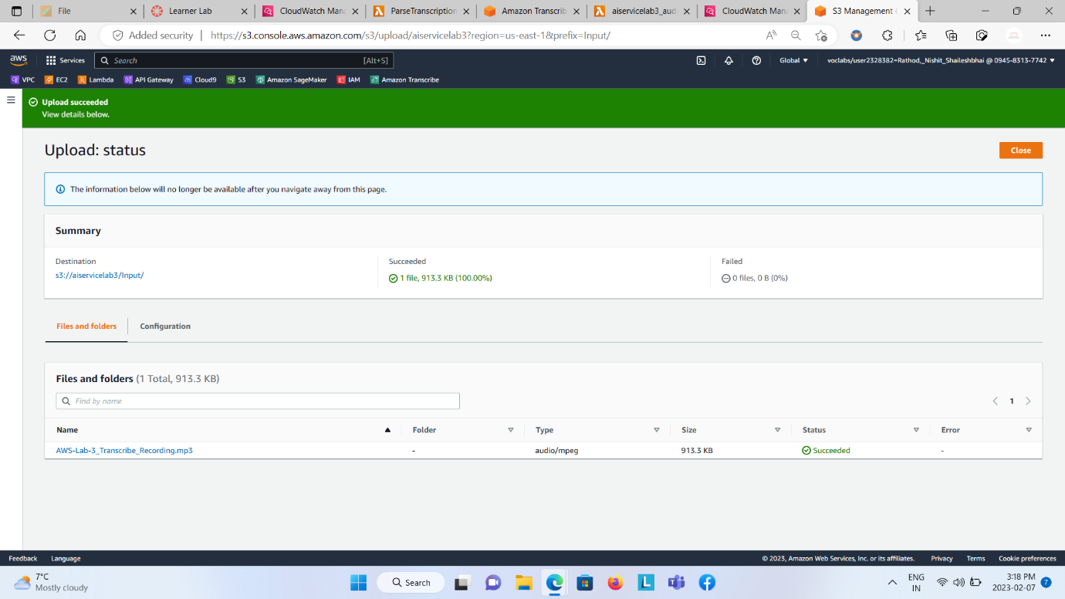

Edit the created event.

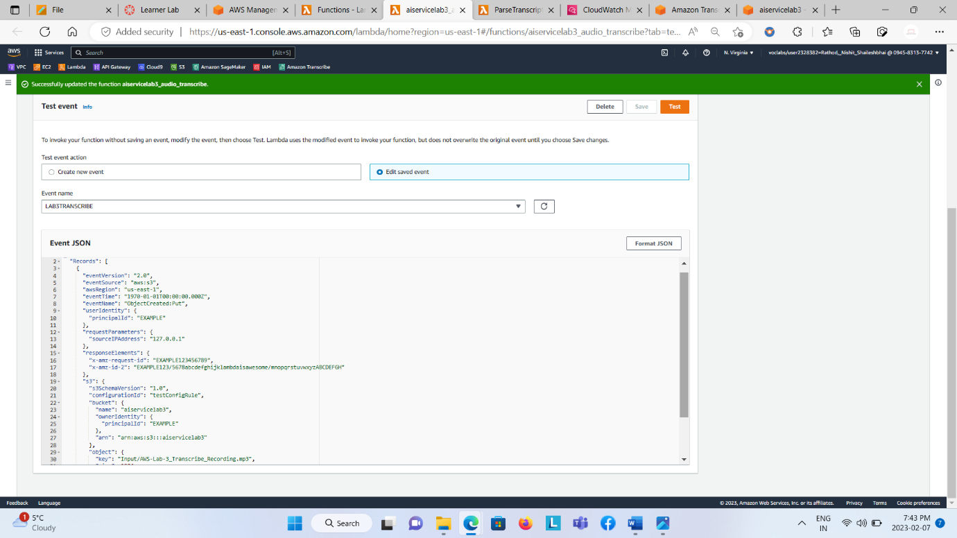

Step 6: Open CloudWatch Logs and see the desired transcribe result.

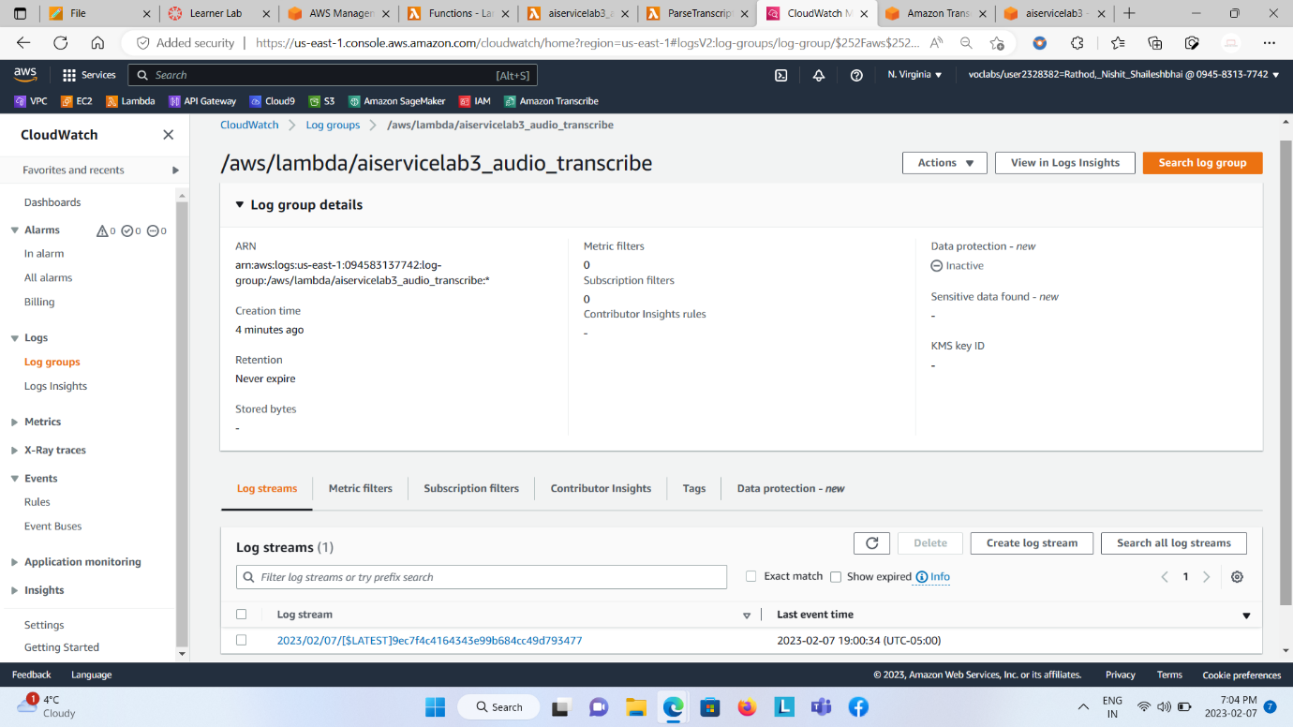  
  
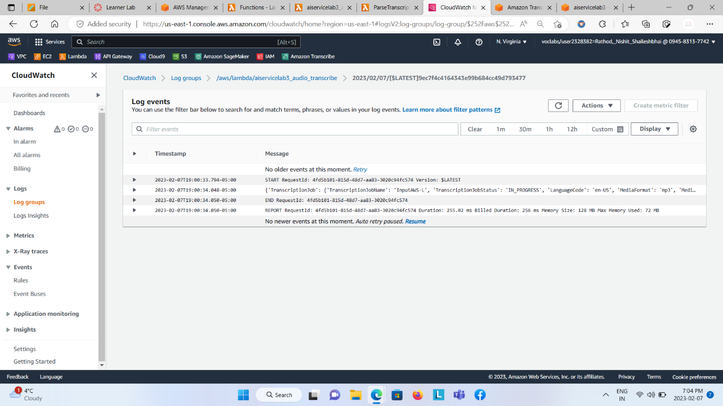  
  
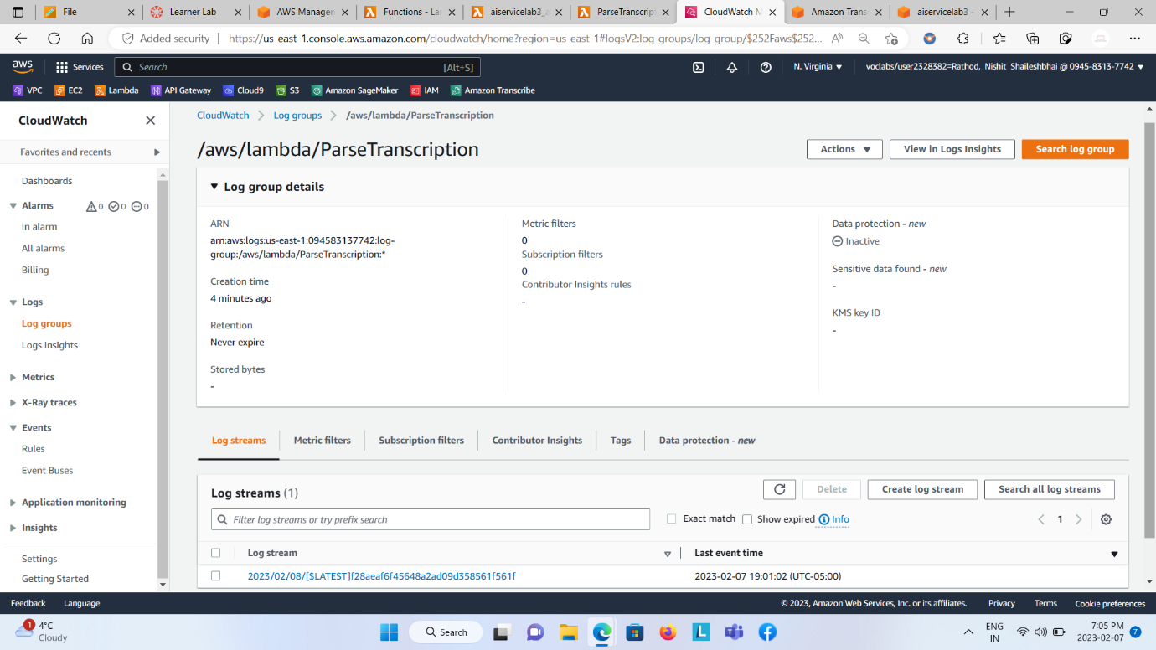  
  
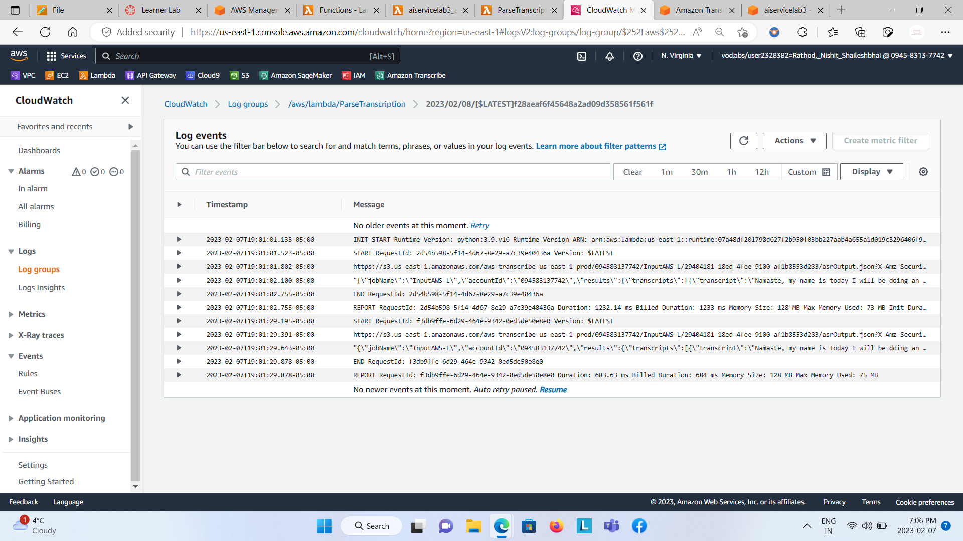  
  
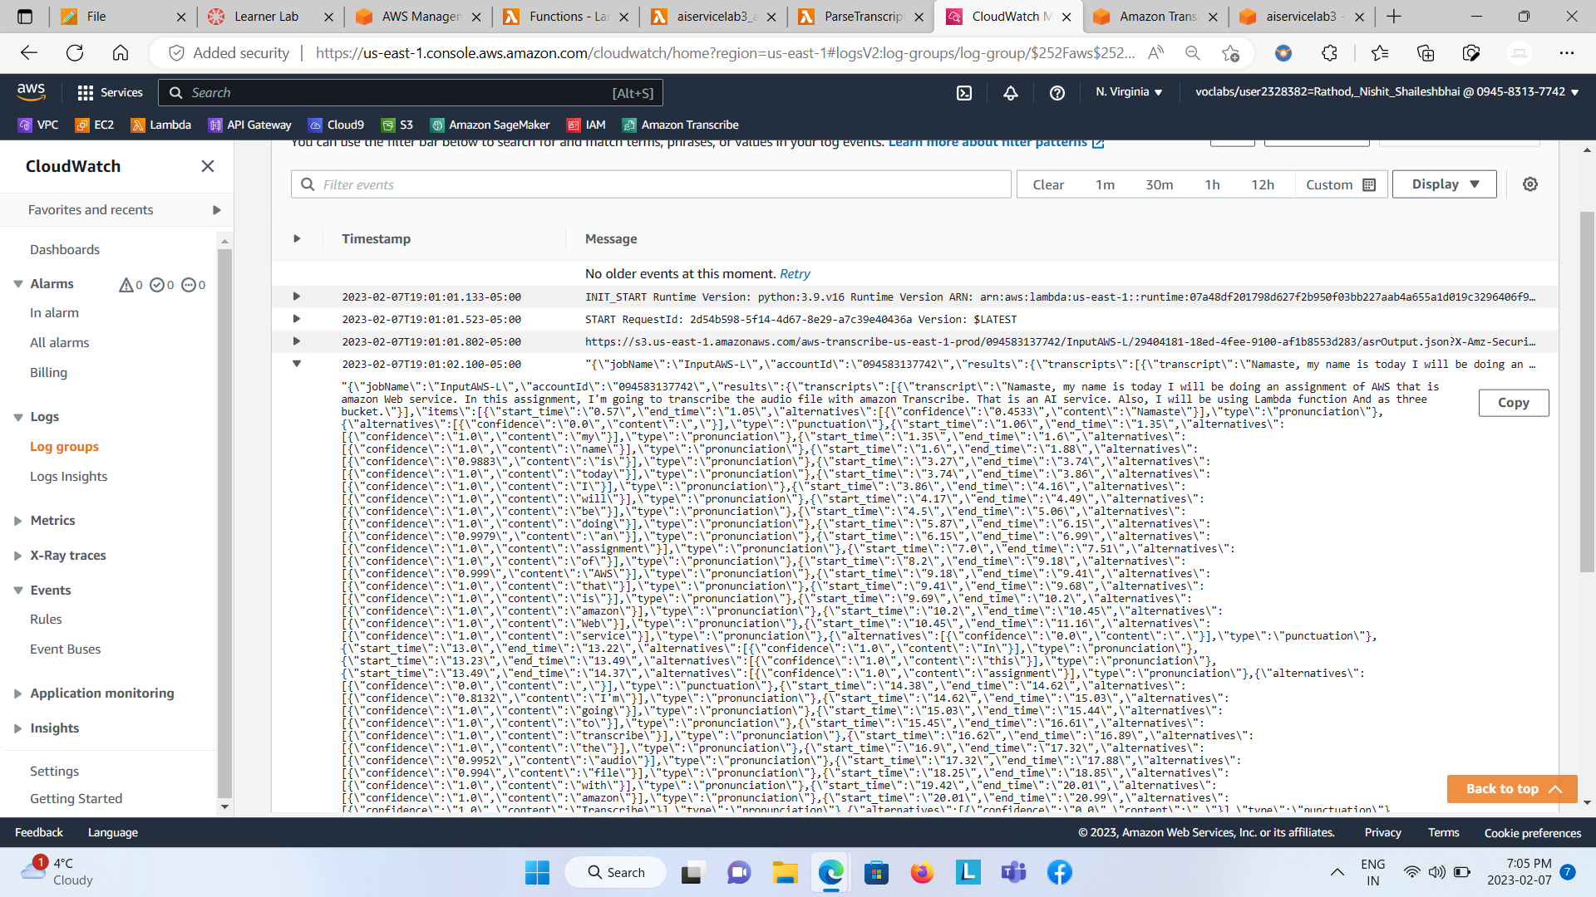

Step 7: Open Amazon Transcribe and Transcription job would be created with defined name.

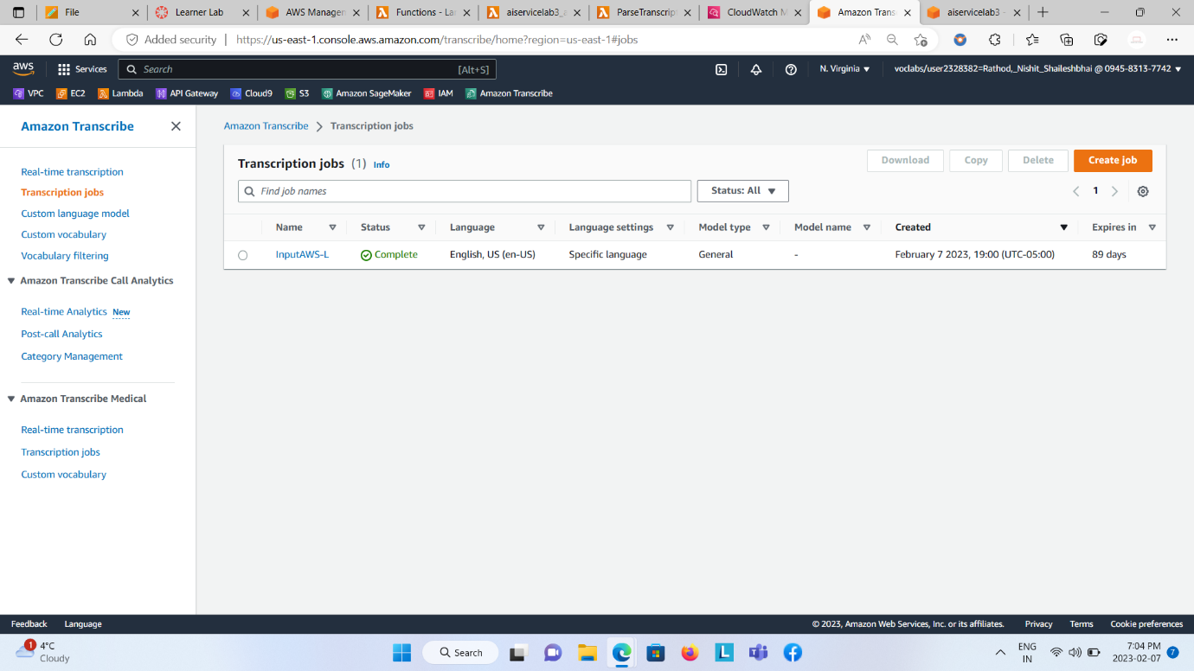  
  
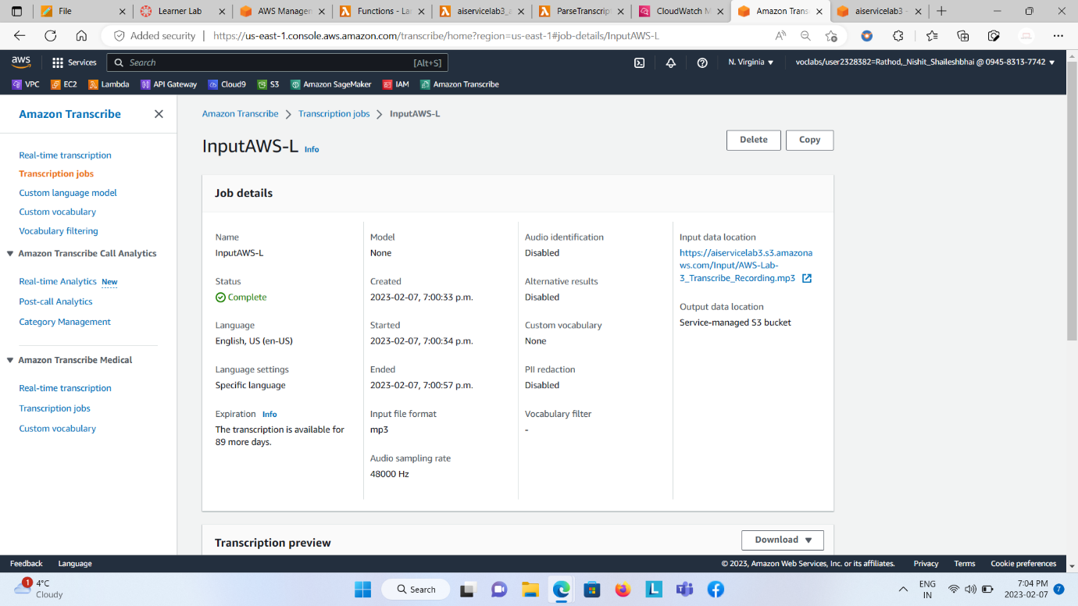  
  
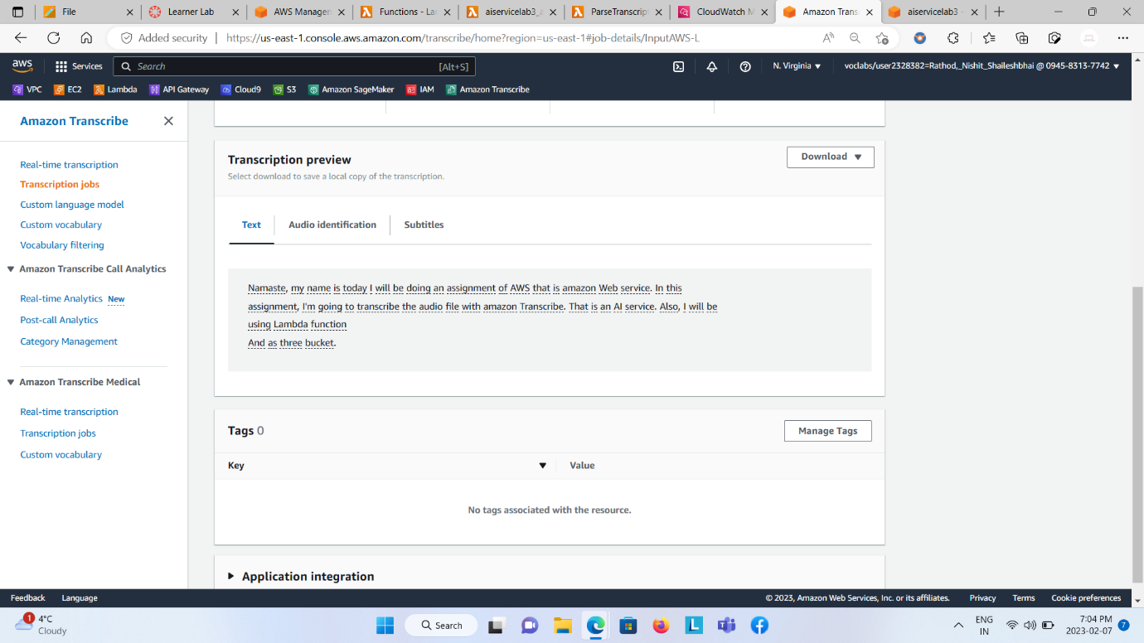

Step 8: Save theresult in .txt file of the transcript from the Transcription job using lambda function two.

